**NAME ……………………………………………. INDEX NO …………………………..**

**SCHOOL …………………………………………… SIGNATURE …………………..………**

**DATE ……..…………………...**

**231/3**

**BIOLOGY**

**PAPER 3**

**(PRACTICAL)**

**13/4 HOURS**

**GOLDEN ELITE EXAMINTIONS 2020**

*Kenya Certificate of Secondary Education (K.C.S.E)*

**231/3**

**BIOLOGY**

**PAPER 3**

**(PRACTICAL)**

**13/4 HOURS**

**INSTRUCTIONS TO CANDIDATES**

* Write your name and Index Number in the spaces provided above.
* Sign and write date of examination in the spaces provided above.
* Answer **ALL** questions in the spaces provided in the question paper.
* You are **not** allowed to start working with the apparatus for the first 15 minutes of the 1**3/4** hours allowed for this paper. This time is to enable you to read the question paper and make sure you have all the chemicals and apparatus that you may need.
* All workings **must** be clearly shown where necessary.
* Mathematical tables and silent electronic calculators may be used.

**For Examiners use only.**

|  |  |  |
| --- | --- | --- |
| **Question** | **Maximum Score** | **Candidates Score** |
| **1** | **12** |  |
| **2** | **14** |  |
| **3** | **14** |  |
| **Total score** | **40** |  |

*This paper consists of 5 Printed pages.*

*Candidates should check the question paper to ensure that all the papers are printed as indicated and no questions are missing*

1. (a) You are provided with a solution L. Using the reagents provided; determine the food compounds in L. Fill in the table below.

|  |  |  |  |
| --- | --- | --- | --- |
| FOOD COMPOUND | PROCEDURE | OBSERVATION | CONCLUSION |
|  |  |  |  |
|  |  |  |  |
|  |  |  |  |
|  |  |  |  |

(b) Place 10mls of solution L in a visking tubing. Tie both ends and place it in 50mls of distilled water contained in a beaker.leave the set up for 20 minutes and make observations.

(i) Observations. (1**mark**)

………………………………………………………………………………………………………………………………………………………………………………………………………………………………

(ii) Account for the observation in b (i) above. (2**marks**)

………………………………………………………………………………………………………………………………………………………………………………………………………………………………………………………………………………………………………………………………………………

(iii) Give the equivalent of a visking in the bodies of living organisms. (1mark)

………………………………………………………………………………………………………………………………………………………………………………………………………………………………

1. 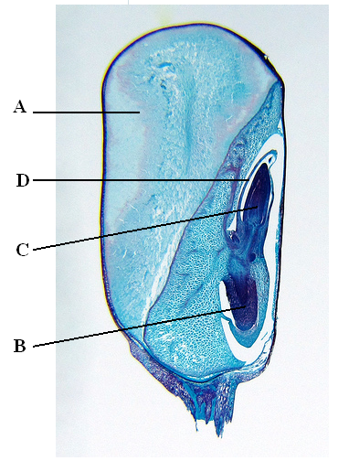Study the photomicrograph of the longitudinal section of a maize fruit below and answer the questions that follow.

1. (i) Name the parts labelled A, B, C and D. (4**marks**)

A

…………………………………………………………….

B

…………………………………………………………….

C

…………………………………………………………….

D

…………………………………………………………….

(ii) Give the role played by A and D. (2 **mark**)

A

………………………………………………………………………………………………………………………………………………………………………………………………………………..….

D

……………………………………………………………………………………………………………………………………………………………………………………………………………………

1. (i) Name the type of germination exhibited by maize grain. ( 1 **mark**)

……………………………………………………………………………………………………………………………………………………………………………………………………………………

(ii) Place the organisms from where the photomicrograph was obtained into its

Kingdom

Division

Class (3**marks**)

(iii) State three characteristics of members of the class identified in b (ii) above (3**marks**)

…………………………………………………………………………………………………………………………………………………………………………………………………………………………………………………………………………………………………………………………………………………………………………………………………………………………………………

1. Give one reason why the maize grain is classified as a fruit. (1**mark**)

………………………………………………………………………………………………………………………………………………………………………………………………………………………………………………………………………………………………………………………………

1. Study the organisms drawn below and answer the questions that follow.

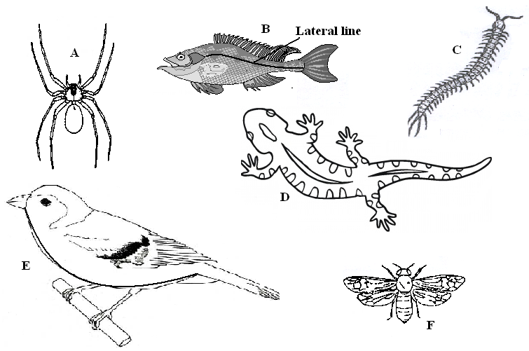

1. Use the dichotomous key below to identify the class the organisms belong to. (12 **marks**)
2. (a) Phylum Chordata ……………………………………………………… go to 2
3. Phylum arthropoda ……………………………………………………. go to 3
4. (a) Has scales on the body ………………………………………………… go to 4

(b) Has no scales on the body …………………………………………..… Mammalia

3. (a) Has cephalothorax ……………………………………………….……. Arachnida

(b) Has no cephalothorax …………………………………………………. go to 5

4. (a) Has fins ………………………………………………………………… Pisces

(b) Has no fins ……………………………………………………………... go to 7

5. (a) Has three pairs of legs …………………………………………………. Insecta

(b) Has more than three pairs of legs ……………………………………… go to 6

6. (a) Two pairs of legs per segment ………………………………………… Diplopoda

(b) One pairs of legs per segment …………………………………………. Chilopoda

7. (a) Has feathers ……………………………………………………………. Aves

(b) Has no feathers ………………………………………………………… go to 8

8. (a) Has a tail ……………………………………………………………….. Reptilia

(b) Has no tail …………………………………………………………….. Amphibia

|  |  |  |
| --- | --- | --- |
| Specimen | Step followed | Identity |
| A |  |  |
| B |  |  |
| C |  |  |
| D |  |  |
| E |  |  |
| F |  |  |

(b) If the actual length from the tip of the mouth to the tip of the tail of the specimen B is 100mm, calculate the magnification. (2**marks**)

…………………………………………………………………………………………………………………………………………………………………………………………………………………………………………………………………………………………………………………………………………………………………………………………………………………………………………